Azure Storage
- Blob Storage
- Queue Storage
- Table storage
- File Storage
Assignment:
Problem Statement: Customer Onboarding & KYC Management Platform on Azure
Business Context
A financial services organization is building a Customer Onboarding and KYC (Know Your Customer) Platform to digitize the customer registration process. The platform must support onboarding of retail and corporate customers, securely store customer information, upload and manage KYC documents, and provide APIs for downstream applications such as CRM, Risk Management, Loan Processing, and Compliance systems.
The solution must be cloud-native, scalable, secure, highly available, and capable of handling millions of customer records and document uploads.
The organization has decided to use:
- Azure App Service (REST APIs)
- Azure API Management (APIM)
- Azure SQL Database
- Azure Cosmos DB
- Azure Blob Storage
- Azure Queue Storage
- Azure Table Storage

Detailed Problem Statement
Functional Requirement 1: Persist Customer and Account Data
When a customer registers through a web portal or mobile application, the platform must capture and persist customer profile information.
Customer Information
The following information must be collected:
- Customer ID
- First Name
- Last Name
- Date of Birth
- Mobile Number
- Email Address
- PAN Number
- Aadhaar Number
- Residential Address
- Occupation
- Customer Category
  - Individual
  - Business
  - Corporate
- Customer Status
  - Pending KYC
  - Active
  - Suspended
  - Closed
Account Information
Each customer may own one or more accounts.
Account details include:
- Account Number
- Account Type
- Branch Code
- Account Opening Date
- Currency
- Account Status
- Relationship Manager

Functional Requirement 2: Upload and Manage KYC Documents
The platform must support uploading customer KYC documents.
Examples:
- Aadhaar Card
- PAN Card
- Passport
- Driving License
- Utility Bill
- Bank Statement
- Corporate Registration Certificate
- Address Proof
Each document can be up to 20 MB.
The platform should:
- Upload documents securely
- Store documents in cloud storage
- Track document metadata
- Support versioning
- Support document retrieval
- Support document validation workflow

Azure Service Requirements
1. Azure API Management (APIM)
All clients must invoke APIs through Azure API Management.
Responsibilities
- API Gateway
- Authentication
- Authorization
- Rate Limiting
- API Versioning
- Request Validation
- Response Transformation
- Developer Portal
APIs Exposure
POST /customers
GET /customers/{id}
PUT /customers/{id}

POST /accounts
GET /accounts/{id}

POST /documents/upload
GET /documents/{id}

GET /customer/{id}/kyc-status

Non-Functional Requirements
- 1000 requests per minute per consumer
- OAuth 2.0 enforcement
- JWT token validation
- API analytics and monitoring

2. Azure App Service (REST APIs)
The business logic APIs must be developed using .NET REST services and hosted in Azure App Service.

Responsibilities
Customer API
Create Customer
Update Customer
Get Customer
Search Customer

Account API
Create Account
Get Account
Update Account

KYC API
Generate Upload URL
Store Metadata
Retrieve Document Details
Check KYC Status

Validation API
Validate PAN
Validate Aadhaar
Check Duplicate Customer

Scalability Requirement
- Support 50,000 customer registrations per day
- Auto-scale based on CPU and requests
- Zero downtime deployments

3. Azure SQL Database
Azure SQL Database will serve as the system of record for structured transactional data.

Data to Persist
Customer Table
CustomerId
FirstName
LastName
DOB
Mobile
Email
PAN
Aadhaar
Status
CreatedDate

Account Table
AccountId
CustomerId
AccountNumber
AccountType
Status
CreatedDate

CustomerAddress Table
AddressId
CustomerId
AddressType
City
State
PostalCode
Country

KYC Verification Table
VerificationId
CustomerId
VerificationStatus
VerifiedBy
VerifiedDate
Remarks

Requirements
- ACID transactions
- Referential integrity
- Customer-account relationships
- High availability
- Point-in-time recovery

4. Azure Cosmos DB
Azure Cosmos DB will be used for fast retrieval of customer profiles and customer activity records.
Use Cases
Customer Profile Aggregation
Store denormalized customer data:
{
"customerId": "CUST1001",
"name": "Saket Karnik",
"status": "Pending",
"accounts": [
{
"accountNumber": "123456"
}
],
"documents": [
{
"documentType": "PAN"
}
]
}

Customer Activity Tracking
Store events:
{
"eventType": "DocumentUploaded",
"customerId": "CUST1001",
"timestamp": "2026-07-31"
}

Requirements
- Low latency reads
- Global distribution
- Flexible schema
- Event-driven updates

5. Azure Blob Storage
Blob Storage will store the actual KYC documents.
Requirements
Documents include:
PAN Card
Passport
Driving License
Aadhaar
Utility Bills
GST Certificate

Blob Organization
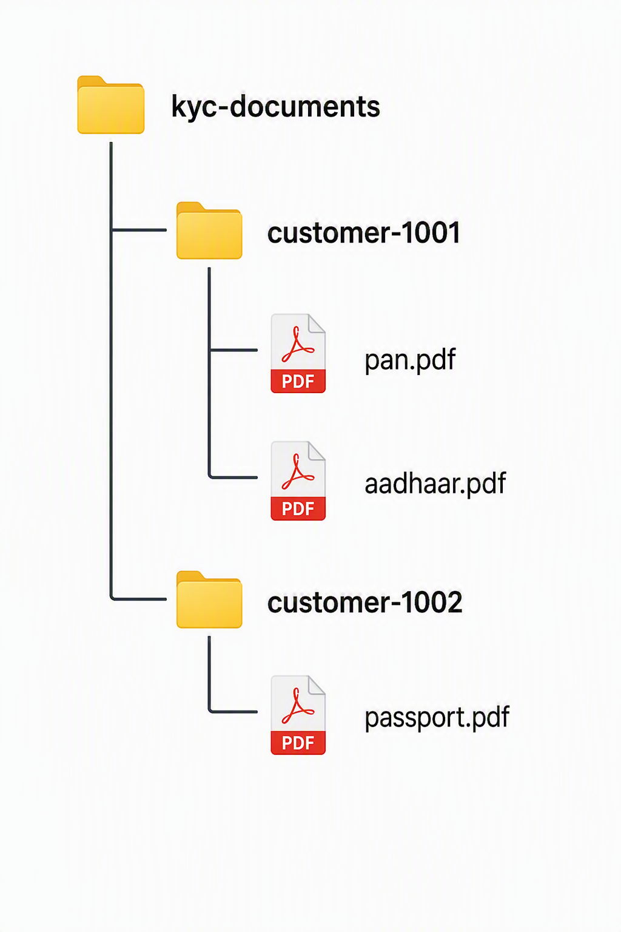

Metadata
Each blob should store metadata:
CustomerId
DocumentType
UploadedBy
UploadedDate
DocumentVersion
VerificationStatus

Security Requirements
- Private containers
- SAS token-based upload/download
- Encryption at rest
- Soft delete enabled
- Versioning enabled

6. Azure Queue Storage
Document validation should be asynchronous.
Workflow
After document upload:
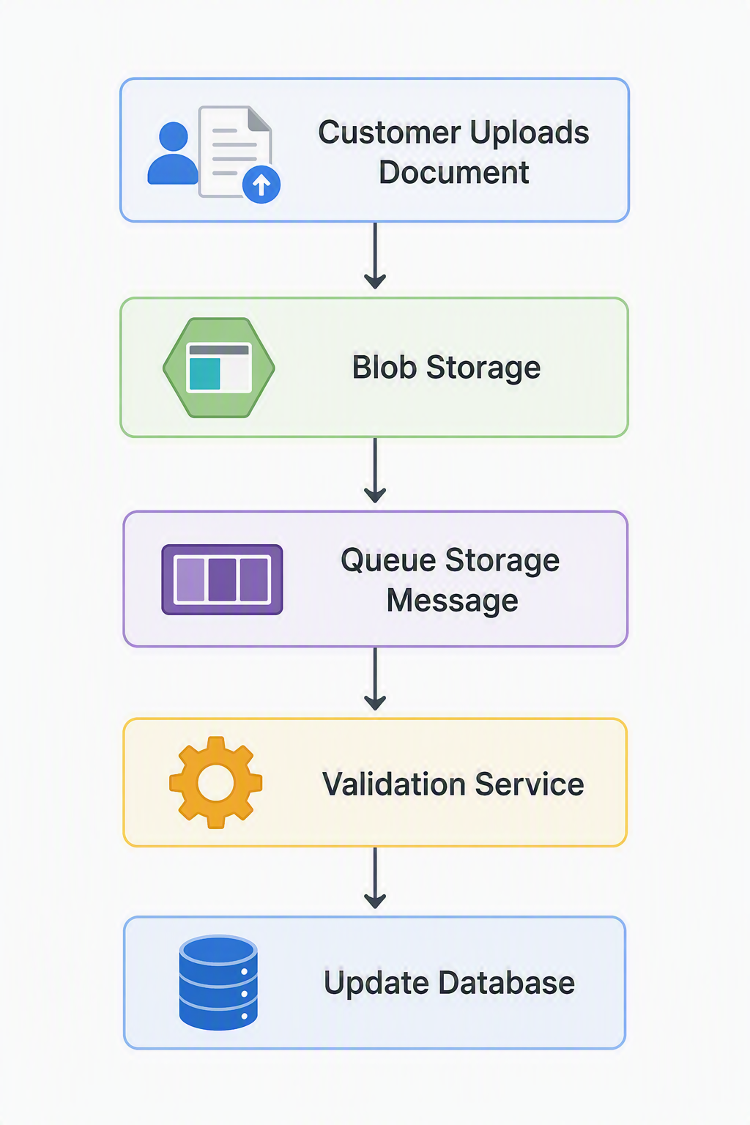
Queue Message Example
{
"customerId": "CUST1001",
"documentType": "PAN",
"blobPath": "/customer-1001/pan.pdf"
}

Benefits
- Decoupled architecture
- Retry mechanism
- High throughput
- Resilience during peak load

7. Azure Table Storage
Table Storage will be used for audit logging and document processing history.
Sample Audit Entry
{
"PartitionKey": "Customer",
"RowKey": "CUST1001",
"Action": "DocumentUploaded",
"PerformedBy": "Customer",
"Timestamp": "2026-07-31T10:00:00Z"
}

Use Cases
- Audit logs
- KYC processing history
- Compliance reporting
- API access logs

End-to-End Workflow

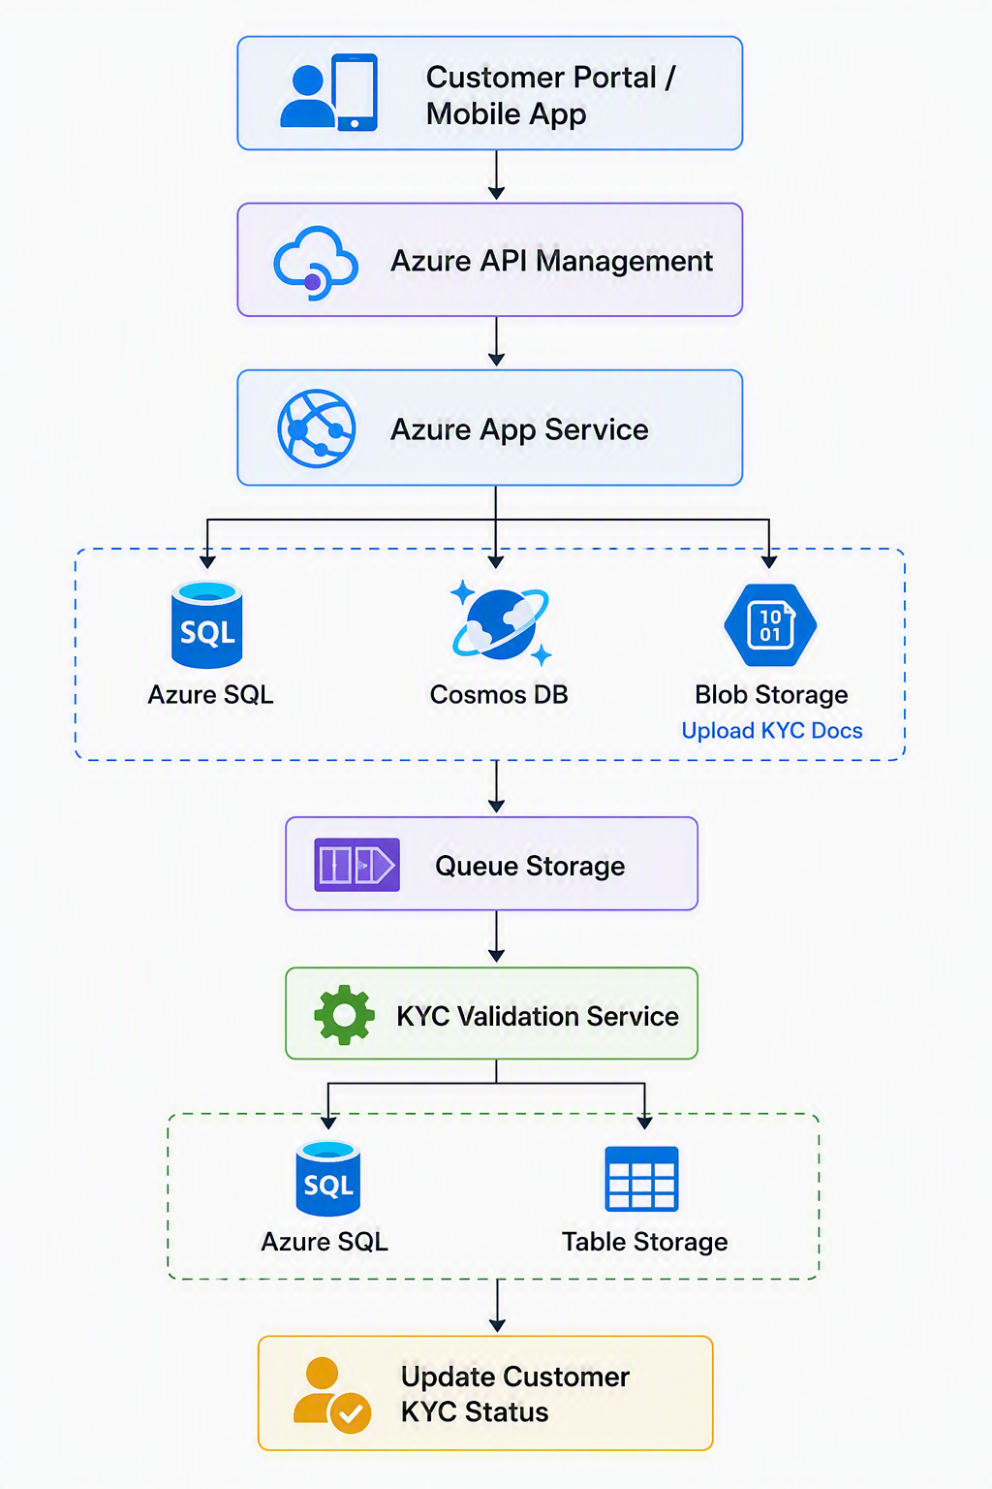

Expected Outcomes
The platform should enable:
- Secure customer onboarding through REST APIs.
- Persistent storage of customer and account data in Azure SQL.
- Storage and retrieval of KYC documents using Blob Storage.
- Fast customer profile lookups using Cosmos DB.
- Asynchronous document validation using Queue Storage.
- Compliance-ready audit trail using Table Storage.
- Centralized API governance through Azure API Management.
- Scalable and highly available deployment through Azure App Service.

